Day 73

DIY

DIY Questions:

1.Write a command to create your internal registry?

Solution:

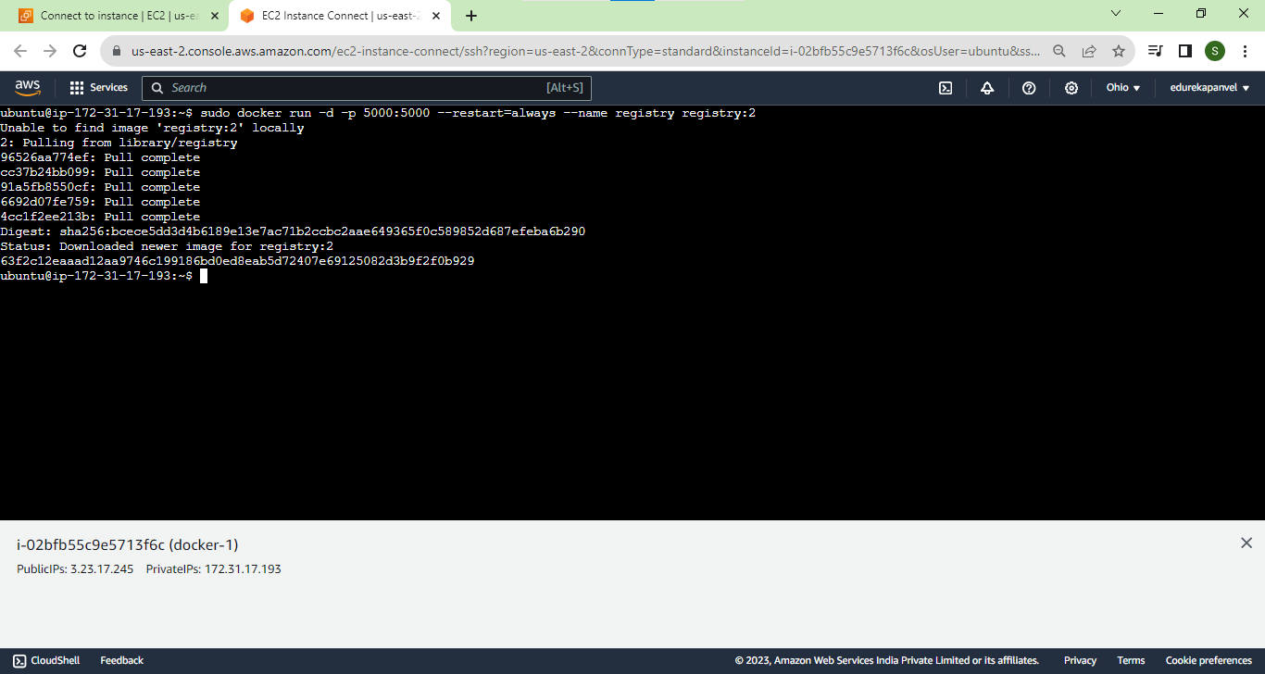



2.Which of the following statement is true about multistage builds?

a)Multistage builds have multiple FROM statements

b)Multistage builds to decrease the size and complexity of created images

c)Allows users to selectively copy resources from the previous build to the new ones

d)All of the above

Solution:

**d)All of the above**

3.Create a two-tier WordPress application using docker-compose

Solution:

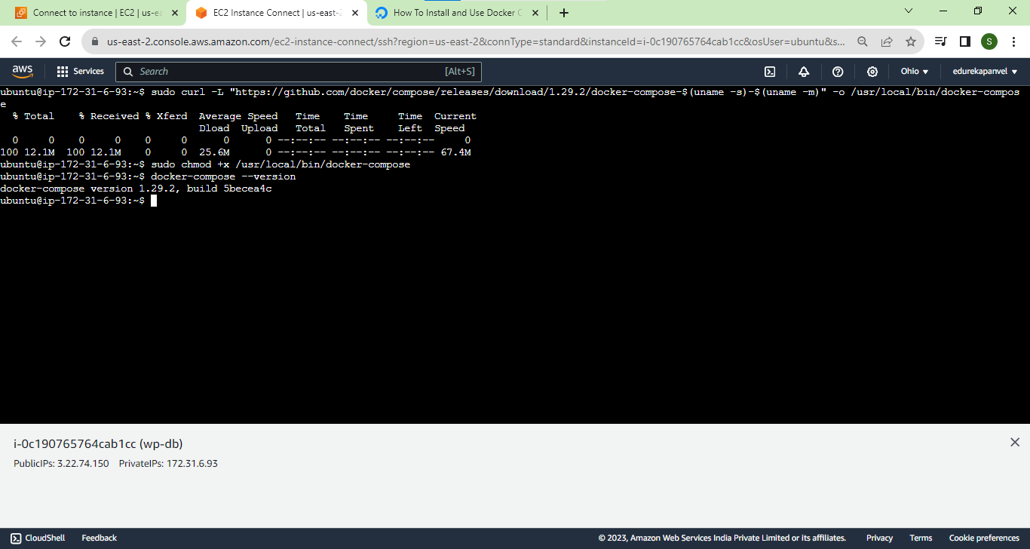

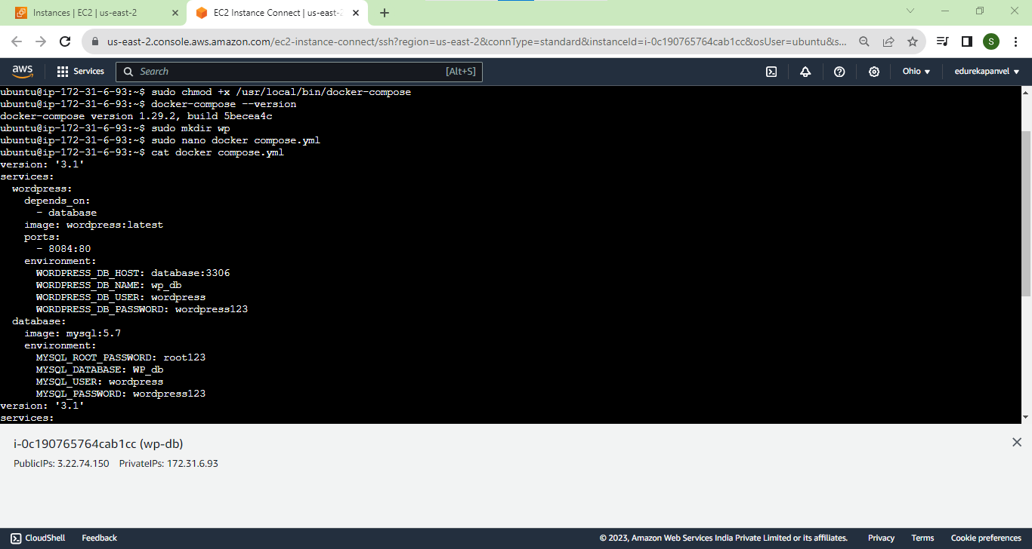

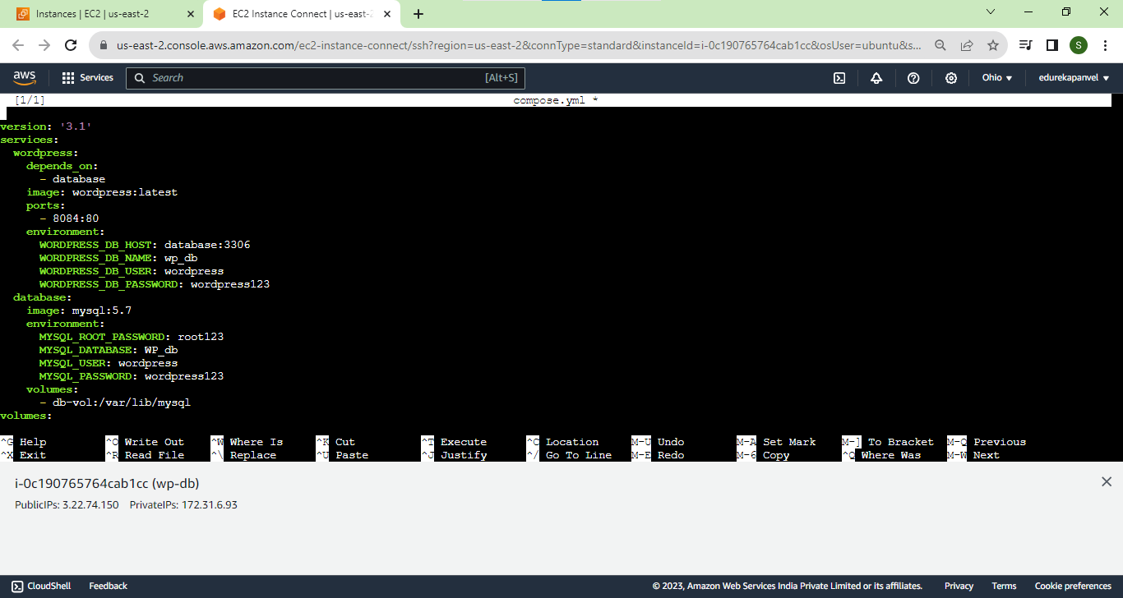

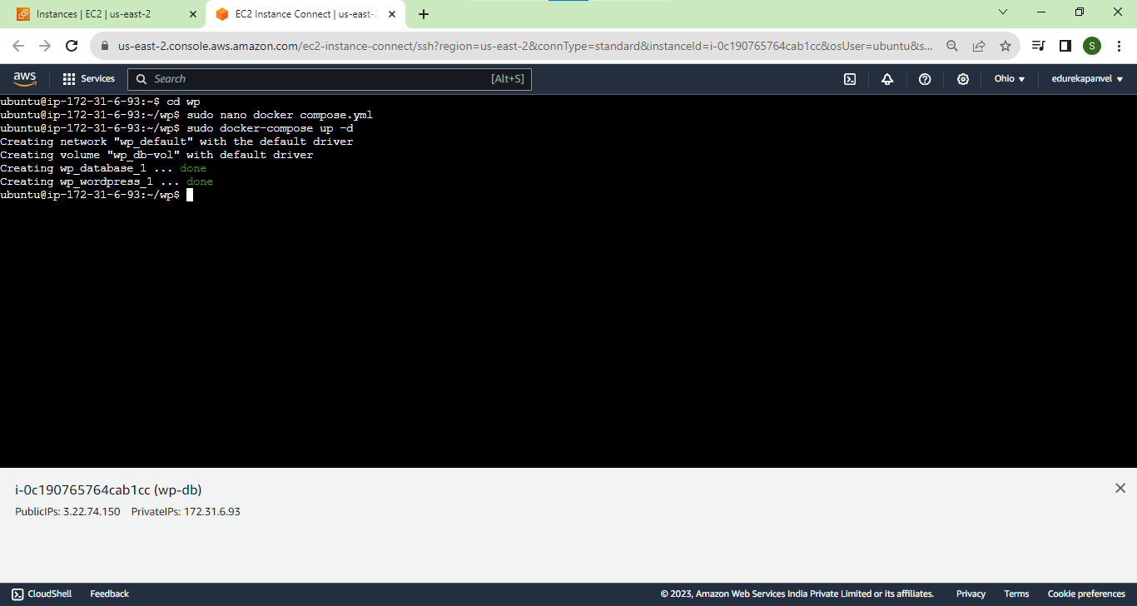

4.Create a docker swarm cluster of two nodes (the first node actingas manager and the second acting as a worker)

Solution:

On node1

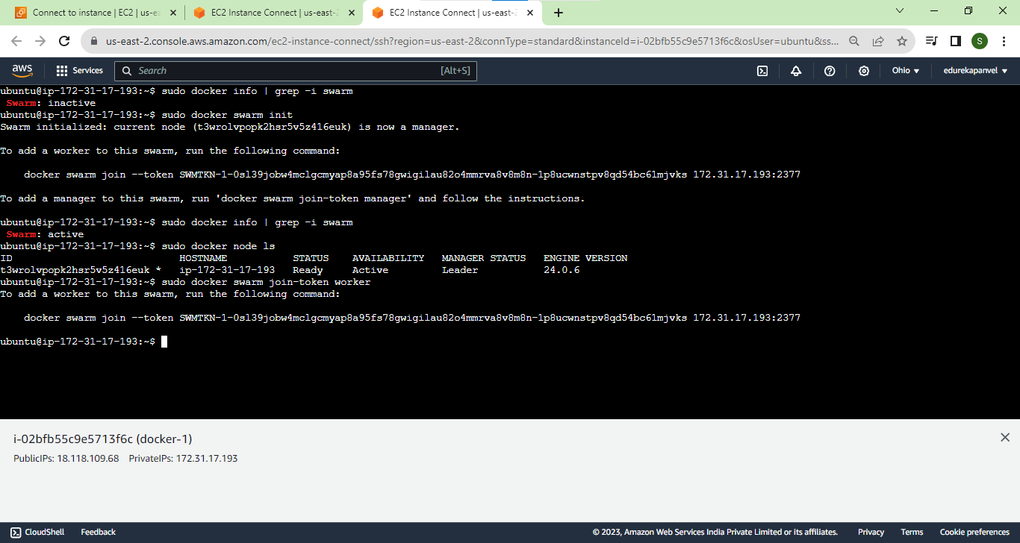



On cluster:  
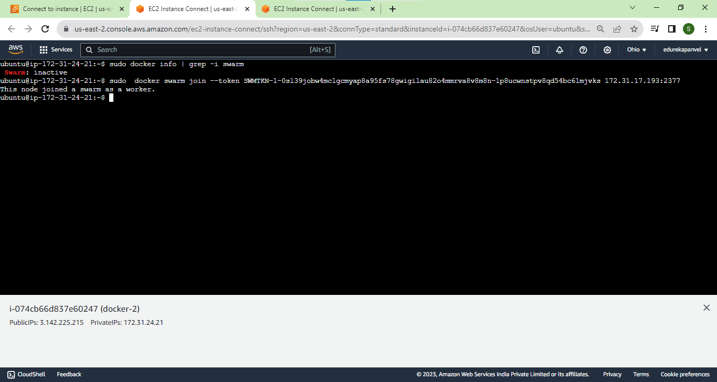

5.How will you use docker-compose to display the details of the running service?

Solution:

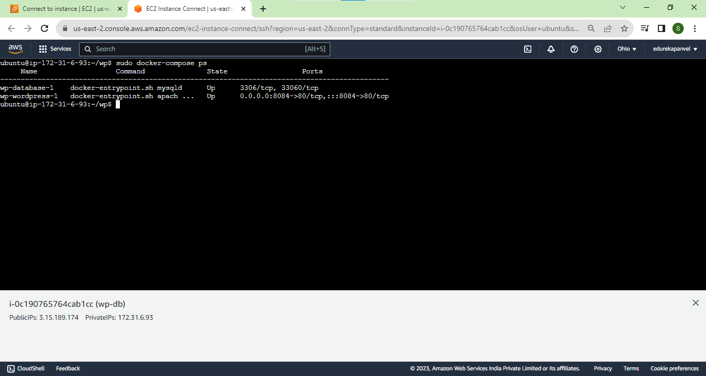

6.How will you use docker-compose to run an application in detached mode?

Solution:

